**GIT**

1. DOWNLOAD GIT: <https://git-scm.com/download/win>

FOLLOW THE STEPS SHOWING IN THE CLASS 4 SECTION 2 OF THE COURSE:

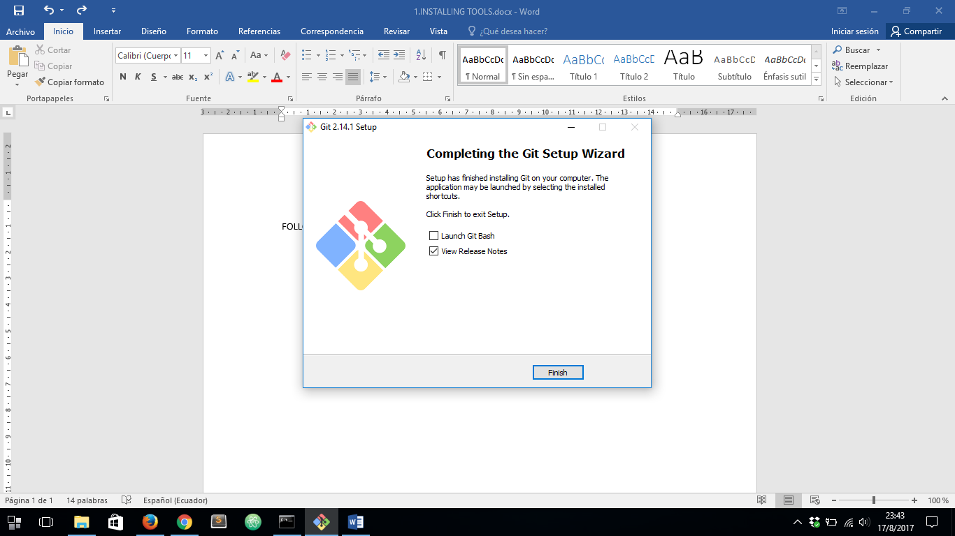

THEN VERIFY IF GIT HAS BEEN INSTALLED CORRECTLY:

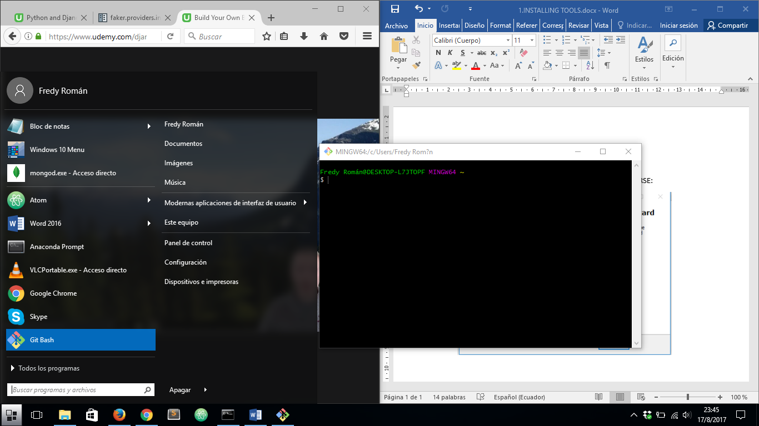

THEN TYPE ***exit*** on Git Bash

**VIRTUALBOX**

1. DOWNLOAD VIRTUALBOX FROM: [***https://www.virtualbox.org/wiki/Downloads***](https://www.virtualbox.org/wiki/Downloads)

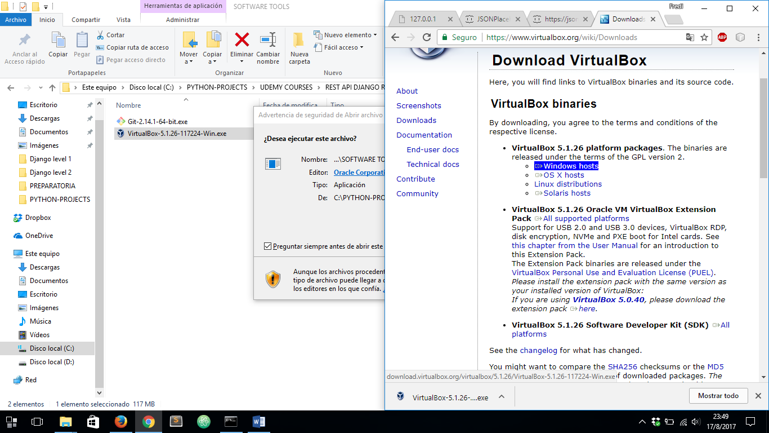

ONCE DOWNLOADED, INSTALL IT:

FOLLOW THE STEPS SUCH AS THEY APPEAR:

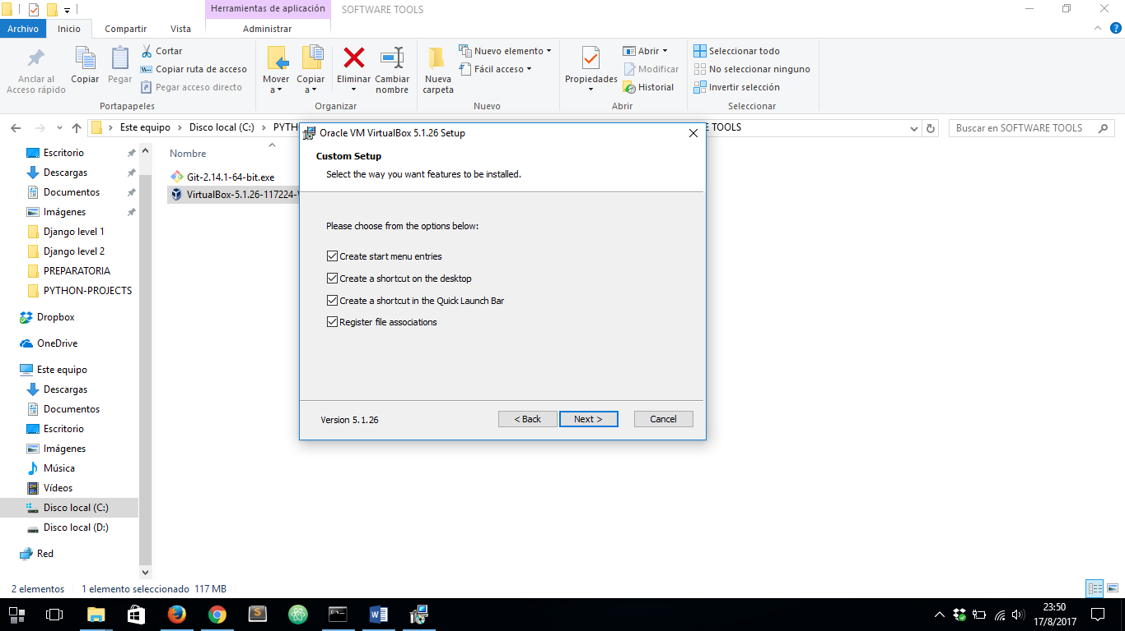

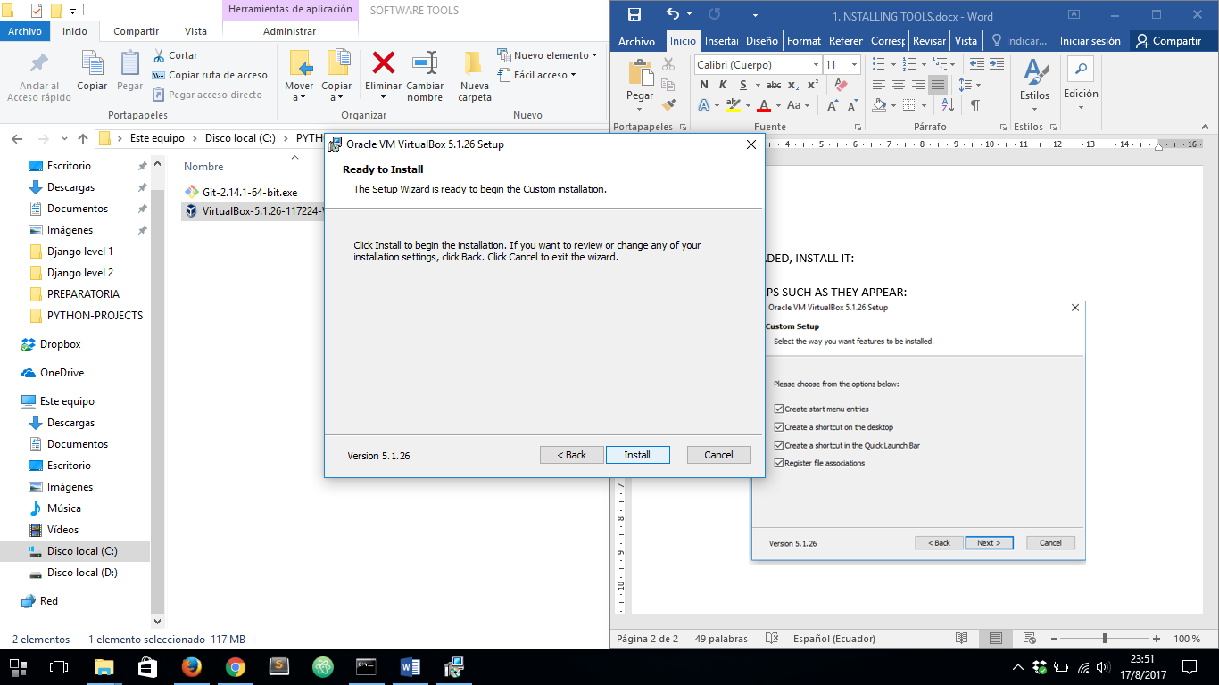

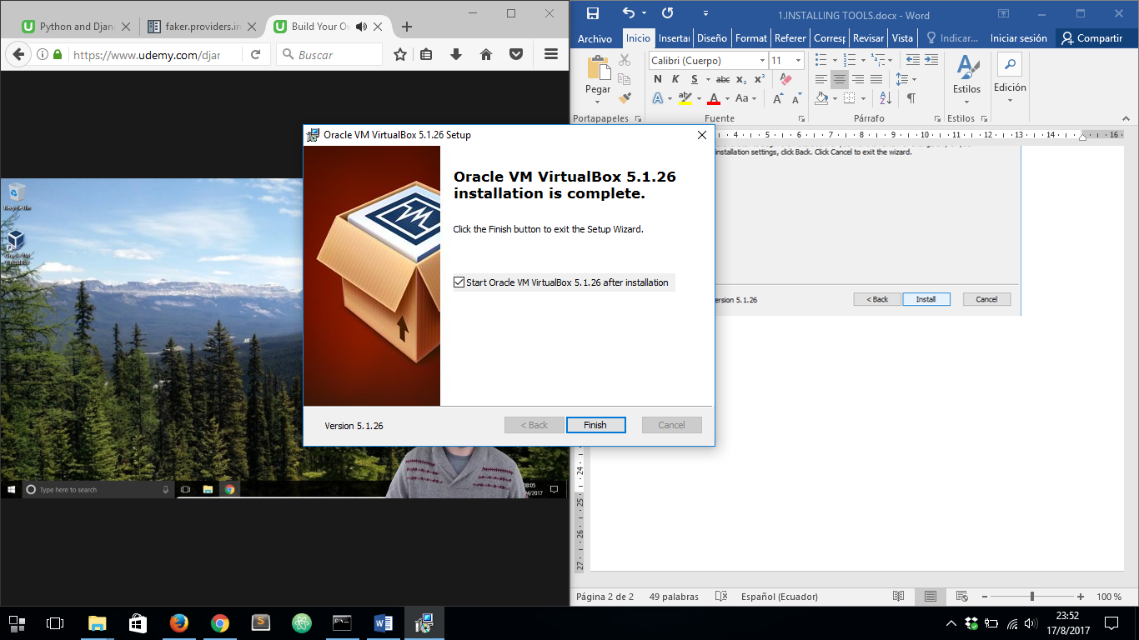

**VAGRANT**

1. DOWNLOAD VAGRANT FROM: https://www.vagrantup.com

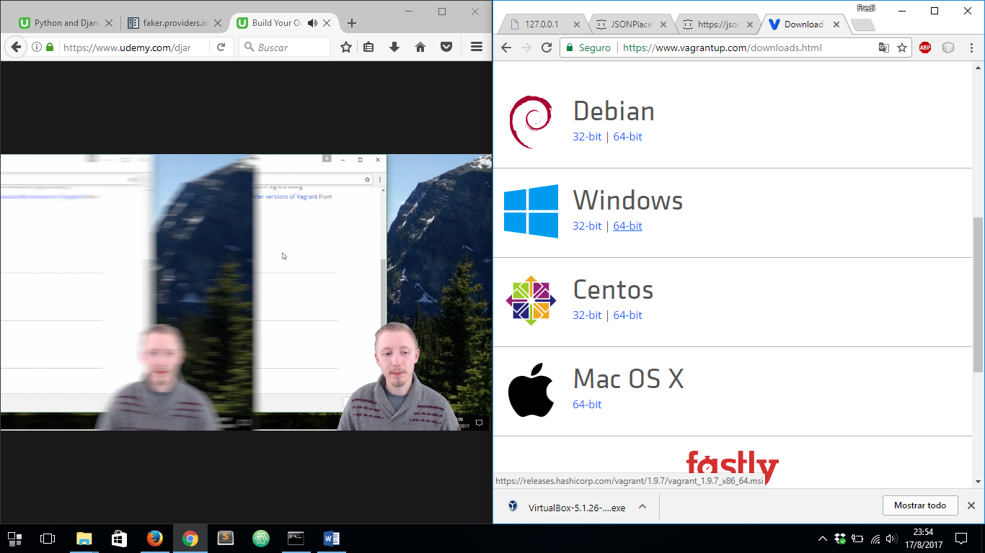

FOLLOW THE STEPS SUCH AS THEY APPEAR:

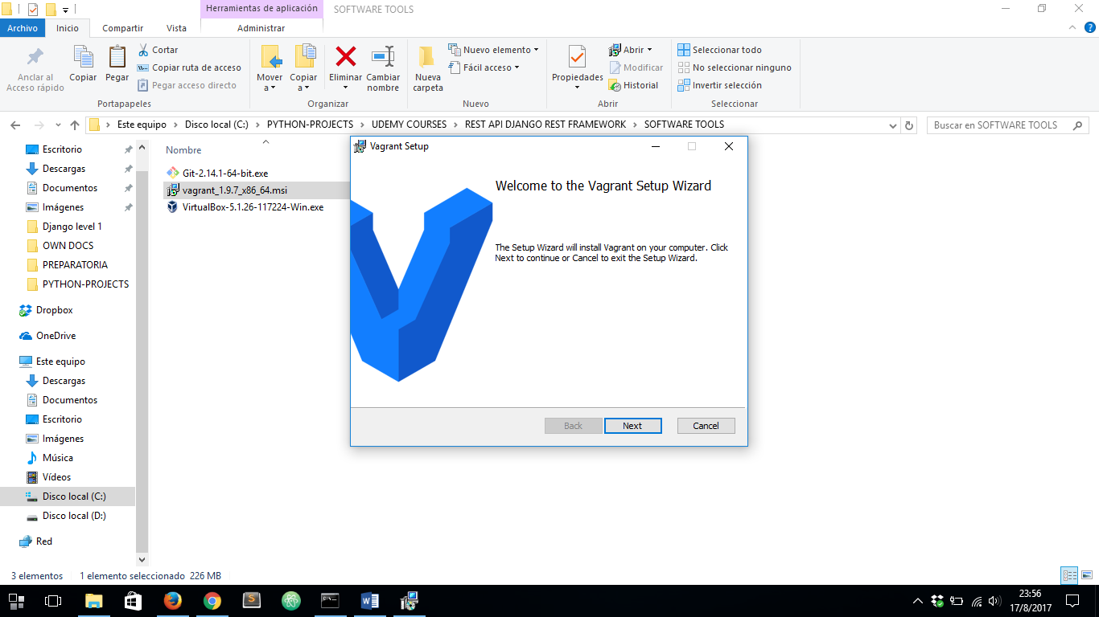

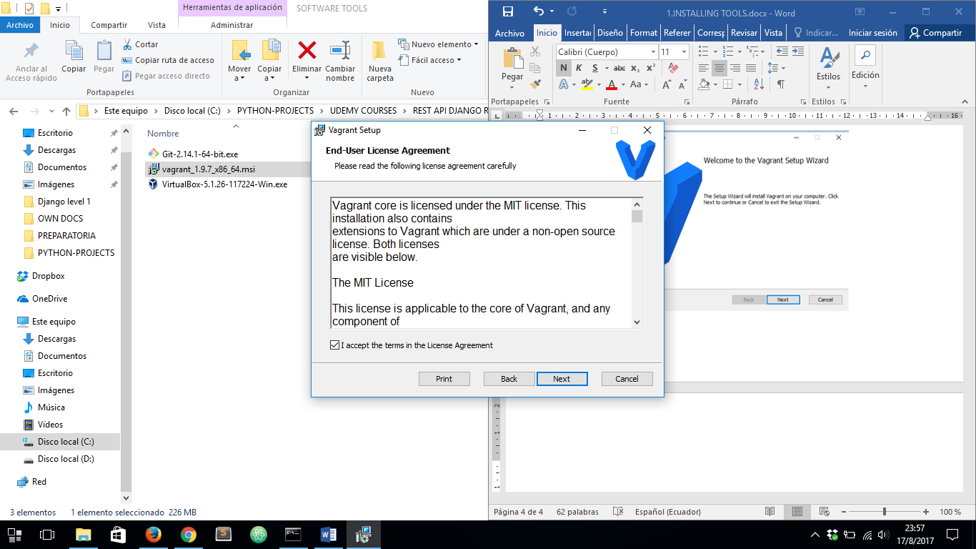



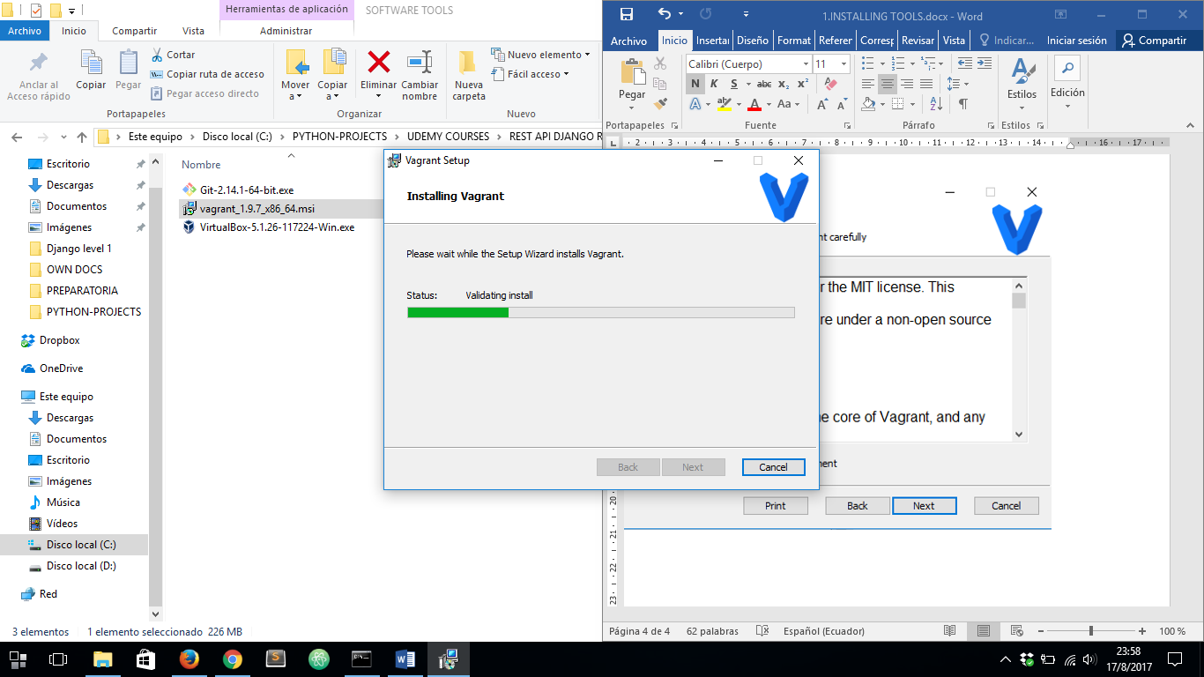

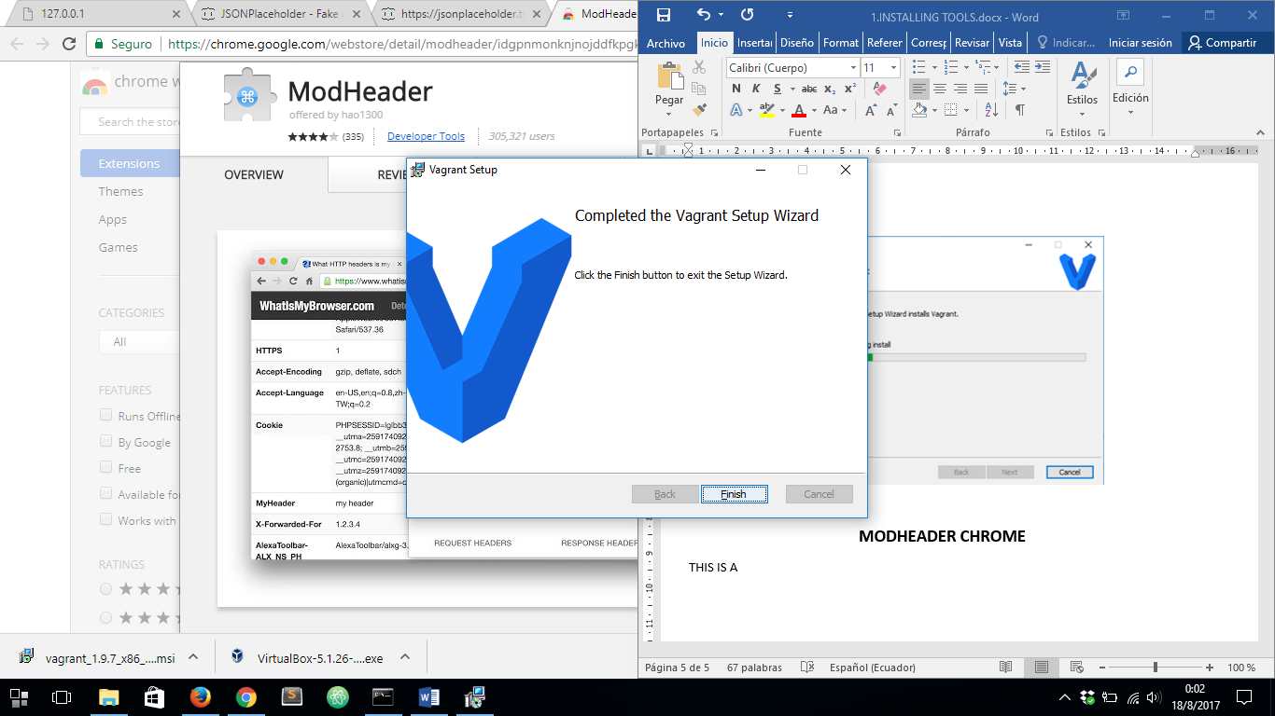

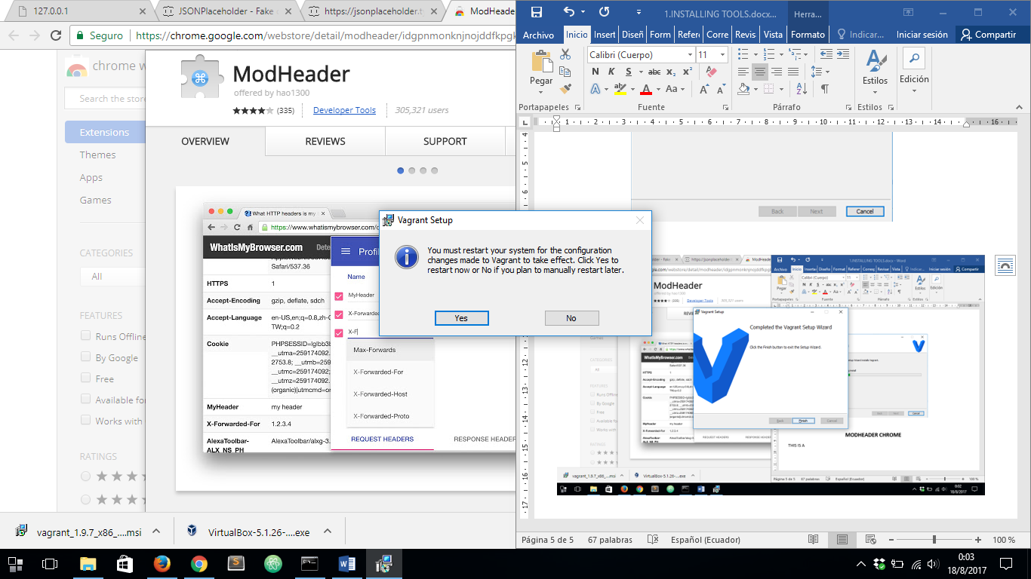

**CLICK YES**

AFTER ALL THESE, OPEN GIT BASH AND TYPE: ***vagrant versión***. IT WILL TAKE A COUPLE OF MINUTES:

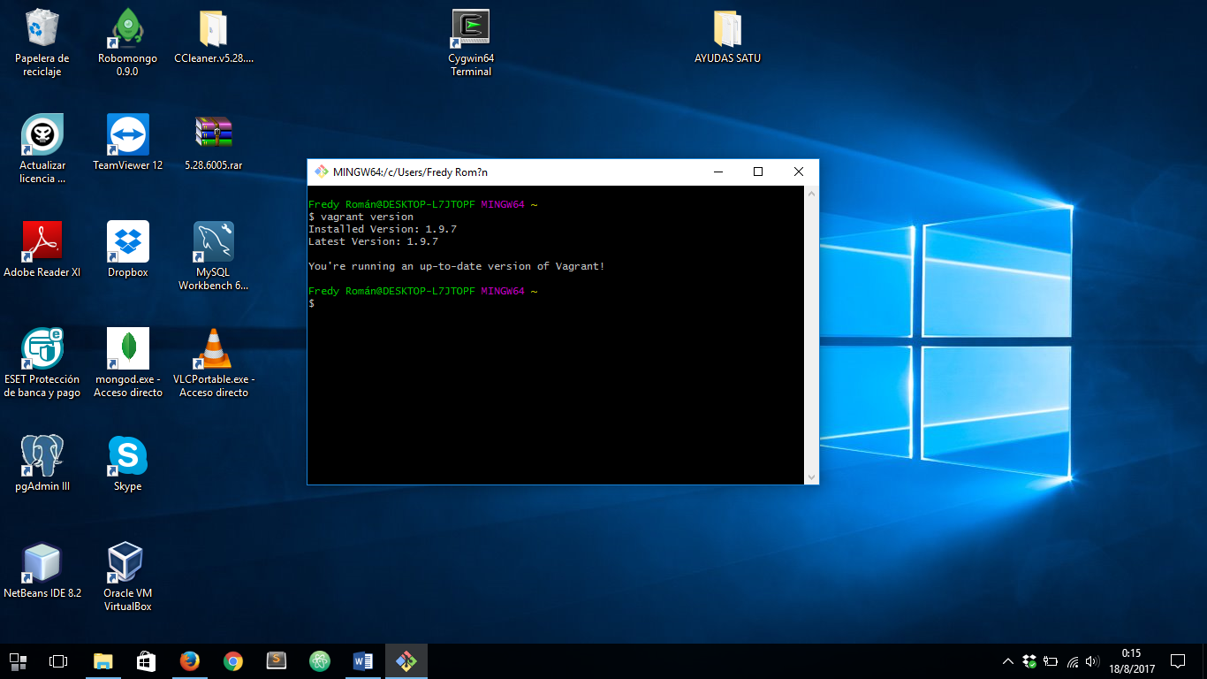

THEN TYPE ***exit***

**MODHEADER GOOGLE CHROME**

THIS IS A TOOL TO CHANGE HTTP HEADERS

1. ADD MODHEADER EXTENSION: <https://chrome.google.com/webstore/detail/modheader/idgpnmonknjnojddfkpgkljpfnnfcklj?hl=en>

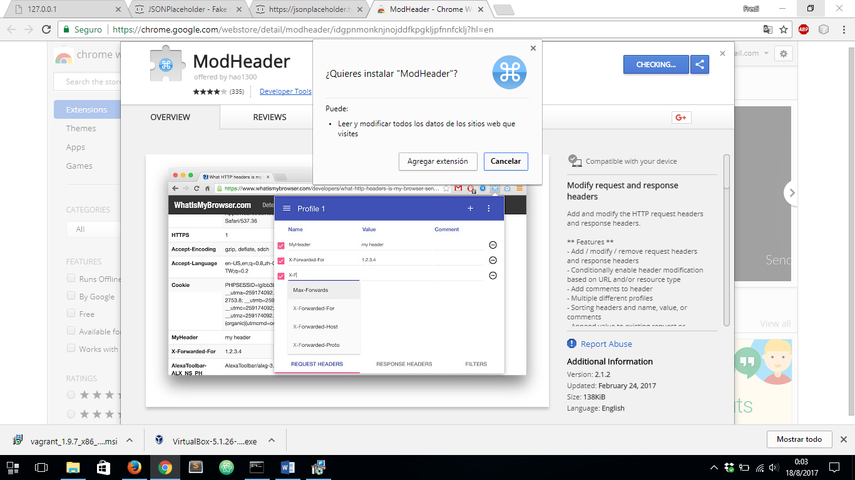

**ATOM IS ALSO NEEDED BY A DEVELOPING TOOL, INSTALL IT IF YOU HAS NOT ALREADY INSTALLED**